Protocol # | Description | Purpose | Reqt/Spec
  Author
Emp004 | Delete User | To verify admin user is able to delete the user record.

Prerequisites | - Standard System Configuration  - User must be logged In to the web interface.  - The user must have Local and system admin privileges.  - At least one employee should be available for the selected location.  - At least one group should be available for the selected location.
Procedure | - Login to the web interface.  - Click on Administration link from the top right menu.  - Click on Users link  ER 1 – User records Screen is displayed.  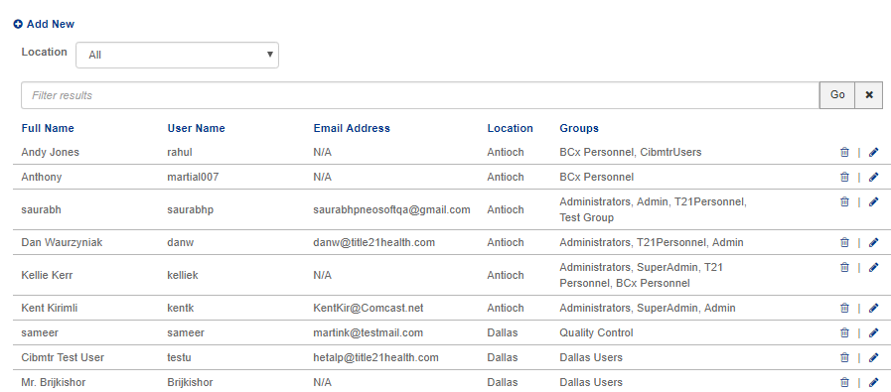  - Click on location drop-down and select the specific location (for eg. Dallas).  ER 2 – Only users of selected location are displayed.  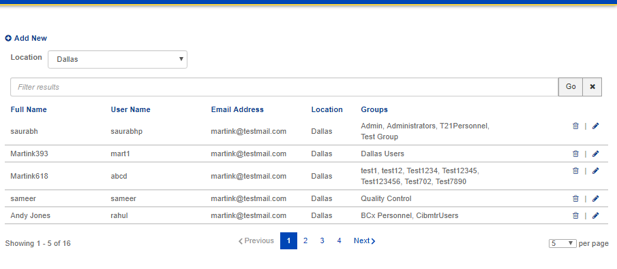  - Click on search filter and enter the user’s name  - Click on Go button  ER 3 – User Record as per search is displayed.  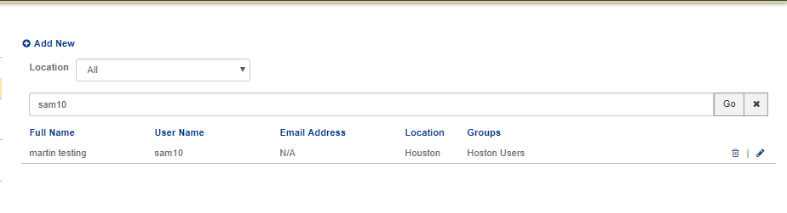  - Click on Delete Button  ER 4 - Delete user popup is displayed.  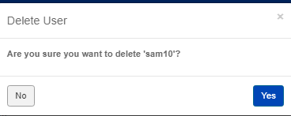  - Click on No button  ER 5 – User should redirected to “user screen”.  - Click on yes button  ER 6 – User get deleted and a message confirming successful deletion of the user is displayed.  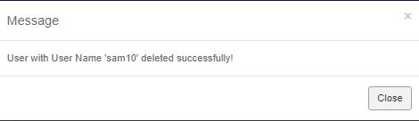  - Click on user search field.  - Enter the username of deleted user.  ER 7 – It should display “no user found” message.  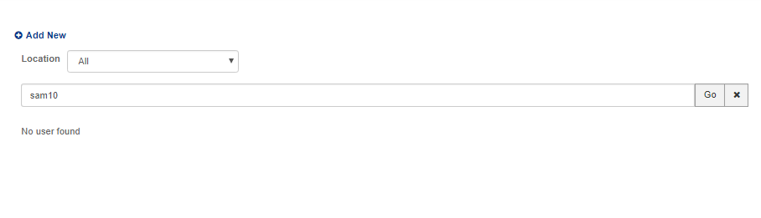  - Go to user list screen  - Find the admin user which you are using  - Click on delete button.  ER 8 – It should display “You can't delete yourself. The main administrator must perform this function.” message.  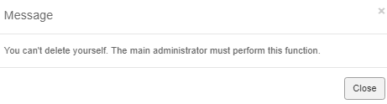
Pass/Fail | Pass:  Fail: | Type of Execution |  | Date:
Pass/Fail | Pass:  Fail: | Automation: | Manual: | Date:
 | Date of Execution:
Notes/Deviations
Additional Remarks in case of Manual Execution
Name of Tester(if Manual)
Test Case Review/Approval | Signature of  Reviewer/Approver: |  |  | Date of Approval:

